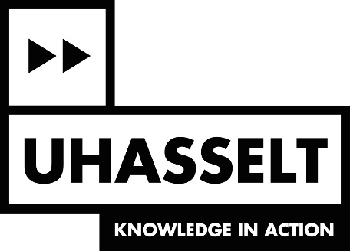

EURECA-PRO MOBILITY CALL
INCOMING MOBILITY

Promoter UHasselt
Partner researcher from EURECA-PRO partner university
Partner university EURECA-PRO | □ Montanuniversität Leoben (Austria)  □ Technische Universität Bergakademie Freiberg (Germany)  □ Technical University of Crete (Greece)  □ Universidad de León (Spain)  □ Silesian University of Technology (Poland)  □ University of Petrosani (Romania)  □ University of Applied Sciences Mittweida (Germany)  □ Université de Lorraine (France)
Collaboration EURECA-PRO | □ existing collaboration  □ new collaboration
Related lighthouse  (if applicable) | □ LH1 Responsible Material Flows  □ LH2 Environment and Water  □ LH3 Sustainable Materials and Products  □ LH4 Clean Energy  □ LH5 Process automation and Industry 4.0  □ LH6: Health and Circular Economy

This application document, duly filled out, has to be sent to:
eureca-pro@uhasselt.be
Only upon reception of a confirmation e-mail, your application has been successfully.
Part I - Data of the applicant

1. Personal data of incoming researcher

Name
First name
Home university
Faculty
E-mail

2. UHasselt promoter

Name
First name
Research group (compulsory)
Research institute/centre (if applicable)

Part II – The short stay (3 days – 3 months)

- Period of the stay

Indicate the period of your stay.
From
Until

- The short stay

Give a description of the R&I cooperation (max. 1 A4).

- Is the topic of the funding request linked to the following (transversal) policies? Please tick the relevant boxes.
☐ Learning
☐ Inclusive
☐ Sustainability
☐ Internationalisation
☐ Civic

- Is your activity related to research and/or valorisation? Please tick the relevant boxes.
☐ Research
☐ Valorisation

