Call for partners: CORNET-TETRA project: The effect of multiple recycling on the properties and applications of (PE) polyolefin films - MultiRec
Packaging is projected to maintain one of the largest target applications for plastics, currently accounting for 39.6 % of the total plastic demand in the EU, fulfilling its functional role to guarantee a high product quality with an attractive appearance for the consumers. However, in the framework of the updated EU directive 94/62/EC on packaging waste, ambitious targets are put forward for the near future: a specific growth of the recycling percentage from 55 % (current) to 70 % in 2030 has been defined for plastic packaging. Striving to a circular economy and countering resource depletion, these challenging requirements are currently provoking a shift from multi-layer packaging concepts to mono-materials solutions. Hence, the extensive (and economically non-viable) separation/sorting schemes and waste stream contamination in recyclates can be largely avoided. More specifically, adding mechanically recycled polyolefin plastic streams into polyolefin packaging films is regarded as a promising route to combat the enormous plastic waste pile ending up in landfills or incinerators. Especially, the re-processing of mono-material polyolefin films, sorted from post-consumer plastic waste, into functional flexible packaging foils for non-food applications, is currently within the technological capabilities. However, even for commodity applications, the recycled foils need to exhibit the appropriate lifetime, mechanical properties, appearance and functional characteristics for their new application. These properties strongly depend on the present additives, also fulfilling a pivotal role in the (re-)processability and the associated degradation of plastics. Therefore, the need to track the concentration distribution and the remaining functionality of these additives in recyclates cannot be underestimated.
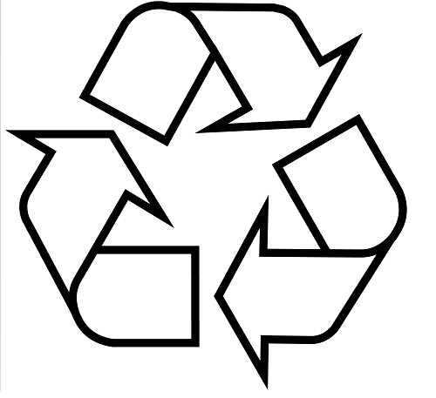
In the current call for CORNET/TETRA projects, research institutes over the entire EU will join forces with the packaging industry in the MULTIREC consortium, to showcase to what extent polyolefin packaging (focus on polyethylene-PE) can be reprocessed and how the functional packaging properties and additive concentrations evolve upon subsequent reprocessing cycles. The support, advice and involvement of the SMEs in the flexible packaging sector is indispensable to reach the ambitious objectives, elaborated in the following paragraphs.
1- Multiple mechanical recycling of virgin and waste polyolefin monomaterials (containing at least 90 % of PE) is performed by research partners in Germany and Poland (Fraunhofer Institute for process engineering and packaging IVV, Wroclaw University of Science and Technology, Fraunhofer Institute for Casting, Composite and Processing Technology). They investigate machine processability of recyclates in blown and cast film processing as well as the impact on functionalities as rheological and mechanical properties, sealing behavior, barrier properties and the coefficient of friction, depending on the type and origin of the waste material. The ecological impact (LCA) of reprocessing will also be studied by these research institutes.
2- Knowledge and insights in the evolution and functionality of present additives during reprocessing will be realized by chemical research at the ACC group (www.uhasselt.be/UH/IMO-services/ACC/Algemeen). Common polyolefin additives will be selected, and added in a controlled way to the matrix material, whereupon the processing-recycling sequence will be initiated. In the intermediate stages, the composition and functional behavior of the plastics will be analyzed, focusing on melting behavior, crystallinity, molecular weight distribution, the degree of cross linking/rigidity, chain scission/backbiting, oxidation and impurities. The additives will be chosen as such that they exhibit a wide range of molecular weights/boiling points affecting their migration/emission behavior, and correspond to the interests of the participating SMEs. The correlations between the loss of these additives throughout the recycling process and the chemical degradation of the host matrix are targeted, to be further translated in specific processing recommendations.
3- The multi-recycled polyolefin films (see 1-) can also find their application as transport packaging (stretch and/or shrink film) of palletized loads or secondary packaging. Analyzing mechanical properties and transport simulating testing of these reprocessed films are crucial, relying on the test infrastructure (www.uhasselt.be/UH/IMO-services/MPRS/Algemeen) and expertise in the research group MPR&S. To increase the understanding in the relationship between reprocessing and application of rPE as transport packaging films (stretch and shrink foils), mechanical and chemical results will be related to each other and compared to virgin material foils.
To successfully carry out this applied research project, Hasselt University calls for companies specialized in raw material production of PE, compounding, packaging (machine) production, waste management and users of this value chain. The participating companies will be asked to join the project in a steering committee, enabling them to integrate their challenges and ambitions in the MULTIREC project research strategy, deliver materials for extensive physicochemical characterization and application testing, access an international research & development EU-network specialized in packaging materials and get first-hand data and results on the incorporation of their products in recycling schemes, allowing to swiftly adapt to the EU policy-imposed context of sustainable and circular packaging. Please respond to this opportunity by filling out the attached letter of intent before 28/01/2022, or contact us.
Contact the Project Consortium
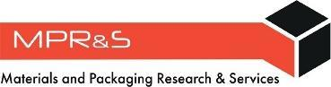
Flanders

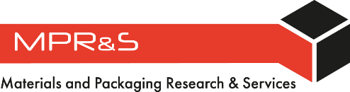  Roos Peeters  Roos.peeters@uhasselt.be | 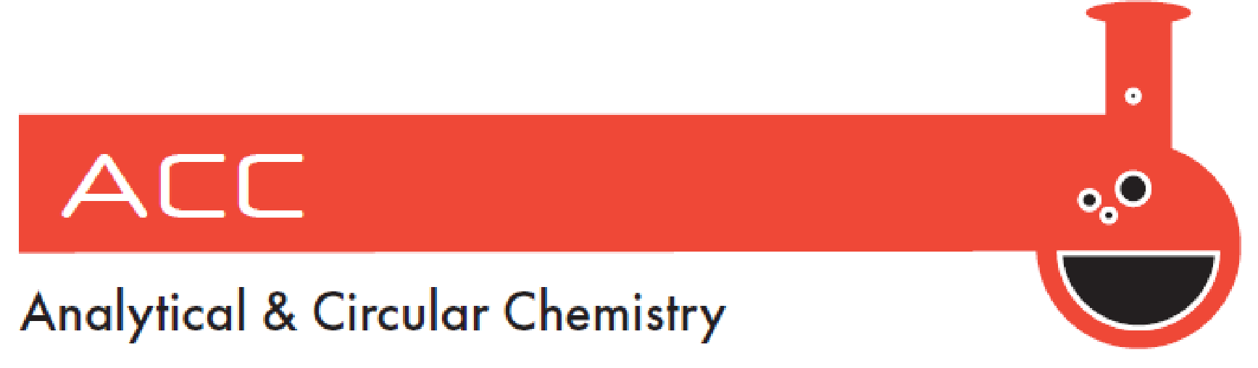  Wouter Marchal  Wouter.Marchal@uhasselt.be
Germany | Poland
  Sebastian Rhein  sebastian.rhein@ivv-dd.fraunhofer.de |   aleksandra.ujcic  aleksandra.ujcic@pwr.edu.pl

Company information, needed for TETRA administration

Organization
VAT. and address
Flemish SME? | Y/N (if not, add type of organization)
Name and function
contact person
Phone
e-mail

After approval of the project application, the above-mentioned company is willing to contribute financially, based on the table below.
Company size (number of employees) | Total project cost
Small: 1 - 50 | €1200
Medium: 50 – 250 | €2400
Large: > 250 | €4500

[company letter heading]
Please insert your company letter heading & address here

The undersigned declares to be aware of the content of the project proposal entitled

The effect of multiple recycling on the properties of polyolefin films (MultiRec)

which will be submitted in the framework of the Joint CORNET Call to the following funding agencies:
- AiF – German Federation of Industrial Research Associations (DE)
- NCBR - National Centre for Research and Development (PL)
- VLAIO, Flanders Innovation & Entrepreneurship (BE)

The proposed project is of interest to the business of [name of company] for the following reasons:
- [two or three specific reasons why the project results will be relevant for the business]

After approval of the project application, the above-mentioned company is willing to be a member of the user committee, to participate in the project and to make clear arrangements in the bylaws of the user committee. The above-mentioned company will delegate an active member to the user committee, which includes participation in two or three Users Committee meetings per project year.
The above-mentioned company acknowledges that they will not be a formal member of the project consortium, that the intellectual property rights belong to the project applicants, and that membership of the users committee does not include any priority rights to the intellectual property. The research in this collective research project is done by research institutes (non-profit organisations).
The above-mentioned company will provide information and feedback to the project consortium to enhance efficiency, focus and direction of the project.

[name and function/position of undersigned]
[date of signature]
[signature]

