CV
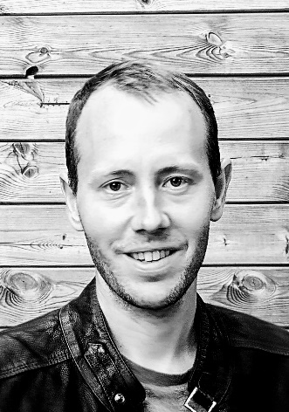
Personal details
- Bram Bamps
- Maastrichtersteenweg 366, 3700 Tongeren
- Mobile nr.: 0489/551-611
- erikson_85@hotmail.com
- https://www.linkedin.com/in/bram-bamps-9194096/
- Born on 21-01-1985 in Tongeren
- Belgian nationality
- Unmarried, de facto unions (Leen Swerts)

Work experience
- 2013–2023: Project engineer / researcher MPR&S, Hasselt university (research + education): writing research plans, acquiring funding, coordinating research, packaging/materials consulting, training
  - Projects.
    - 2023/March: 2 VLAIO-TETRA-CORNET proposals are submitted:
      - “BeFORE: Recyclable material innovations for ’contact sensitive’ plastic and paper packaging with high quality barrier properties”; Project type:
      - “MULTIREC: Effect of multiple recycling on the properties of polyolefin films”
    - 2022: “REPAC²: Functional & recyclable coated paper packaging for food
products”; Project type: VLAIO-TETRA-CORNET
    - 2021: “BIOFUN: Evaluation of functionalities of new generation compostable bioplastics in food packages”; Project type: VLAIO-TETRA
    - 2019–2020: “Optimal peelable seals in packaging concepts undergoing thermal processing”; project type: VLAIO-TETRA-CORNET
    - 2016-2018: “Evaluation and Optimization of Contaminated Seal Performance for Food Packaging”; project type: VLAIO-TETRA-CORNET
    - 2015-2016: “The potential of ultrasonic sealing in packaging concepts”; project type: VLAIO-TETRA
    - 2012-2014: “Functional and sustainable packages”; project type: VLAIO-VIS-Trajectory
  - Bilateral services: mechanical tests (seal + tensile tests) + organisation of workshops, training for companies
  - Packaging diagnosis, in collaboration with Fost Plus and Valipac: looking for quick-wins to improve sustainable potential of packages of Belgian companies
  - Union delegate (ACOD)
- 2012–2013: Project engineer Packaging Center XIOS Hogeschool Limburg
- 2008–2012: Teacher secondary school Koninklijk Atheneum (gemeenschapsonderwijs – ASO) te Tongeren
  - Courses: Geography (3rd grade), supervisor project intellectual giftedness (all grades), biology (2nd + 3rd grade), chemistry (3rd grade), computer science (2nd grade), mathematics (1st + 2nd + 3rd grade)

Education
- 01/10/2021-02/12/2022: Doctor of Engineering Technology
  - “Study of the optimal heat seal performance of flexible food packaging, using material properties, machine and processing parameters in a design of experiments approach”; promotor: Prof. Dr. Roos Peeters, copromotors: Prof. Dr. Ir. Mieke Buntinx and Prof. Dr. Ir. Wim Deferme
- 2006-2008: Master of science in industrial engineering option biochemistry in the Katholieke Hogeschool Limburg in Diepenbeek
  - Internship
    - 2008: 14 Weeks in IMO/UHasselt in Diepenbeek (Bio-electronics)
- 2003-2006: Professional bachelor in biomedical laboratory technology option pharmaceutical and biological techniques in the Erasmus Hogeschool in Brussels
  - Internships
    - 2006: 13 weeks in the DNA Lab of AZ-VUB Jette (molecular genetics)
    - 2006: 7 weeks in FARC/VUB Jette (cell biology)
- 1996-2002: Secondary school mathematics-science in “Koninklijk Atheneum” in Tongeren
- Additional education
  - 2019-2020: Lifestyle coaching in Syntra Limburg
  - 2008-2011: Teacher degree in Centrum voor Volwassenenonderwijs Limburg in Diepenbeek
  - 01/10/2021-02/12/2022: Doctoral schools S&T (UHasselt)

Languages
- Native language: Dutch
- Good knowledge of English, basic knowledge of French

Informatics
- Good knowledge of Microsoft Office
- Basic knowledge of statistical software JMP® (used to set up and analyse experimental designs), OriginPro® (used to fit sigmoidal curves)

Varia
- Political experience: 2012-2018: group leader sp.a (city council Tongeren), president commission welfare, finance, social affairs and inter-municipal cooperation
- Hobbies: Music, sports, politics, TV, reading, lifestyle, science
- Stress management: Good performance under peak stress
- Attitude: Autonomous, rational, strategic, just, guiding

