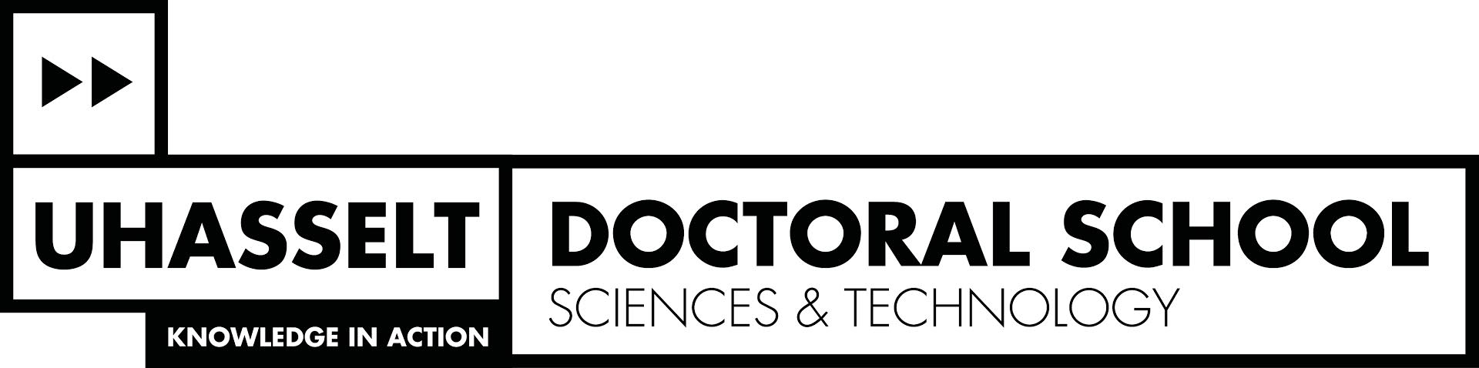

Proposal Adapted Doctoral School Program

Name PhD student: ………………………………………………………………………………………………………………………………
Name promoter: ………………………………………………………………………………………………………………………………
Start date PhD: ……………………………………………………………………………………………………………………………………
Faculty/School: ……………………………………………………………………………………………………………………………………

PhD students preparing a UHasselt PhD
An adapted DS-program is only possible if you are in one of the following two situations:

a. PhD students who are present at Hasselt University for a total of more than 12 months (cumulative) throughout the entire process of their PhD, but not full-time and who have no opportunities to follow DS-activities in their home country (e.g. PhD students with a VLIR-UOS scholarship);
The adapted DS-program must reflect the time that the PhD student is present at Hasselt University. The requirements related to scientific output are always mandatory.
b. PhD students who carry out their PhD research at Hasselt University on average 3 months per year (or max. 12 months in total during the PhD period) (e.g. PhD students with a BOF-BILA Scholarship)
- The adapted DS-program must reflect the time that the PhD student is present at Hasselt University. The requirements related to scientific output are always mandatory.
- In exceptional situations, the promoter and PhD student can decide that it is not possible to follow the DS-program. In this case, the requirements related to scientific output are mandatory and the PhD student will not receive a certificate from the DS after their defense.
In both situations (a and b) the PhD student and promoter propose an adapted DS-program and submit this proposal to the coördinator of the Doctoral School of Sciences & Technology within 6 months after the start of the PhD. The proposal will be submitted for approval to the DS Board of the DS S&T.

PhD students of the DS S&T who prepare a UHasselt PhD but are (almost) never present for their PhD research at Hasselt Univeristy and who are not on the payroll of UHasselt can be exempted from fulfilling the DS-requirements. The requirements related to scientific output are always mandatory.

PhD students preparing a joint PhD
Depending of Hasselt Univerisity is the home or partner institution, you respectively will or will not need to fulfill the DS-requirements. Please check your joint PhD agreement.

In consultation with my promoter, I request to be exempted from fulfilling the following components of the doctoral school program

Arguments:
(please add proof where necessary)

Date and signature:
PhD student Promoter

